###### CURRIDABAT HIGH SCHOOL

**7-1, 7-2, 7-3**

**7-4, 7-5, 7-6**

**ENGLISH DEPARTMENT**

**Practice # 2 First Period // 2020**

**Teacher: Lydia Villegas J. H**

**STUDENT:** __________________________

**Parent’s Signature ________________**________

🎔**FILL IN THE FOLLOWING CHART WITH THE MISSING INFORMATION.**

|  |  |  |  |
| --- | --- | --- | --- |
| MONTHS OF THE YEAR | | | |
| 1. January | 2.  _______________ | 3. March | 4.  _______________ |
| 5.  _______________ | 6. June | 7. July | 8.  _______________ |
| 9. September | 10. October | 11. _______________ | 12. December |
| DAYS OF THE WEEK | | | |
| 1. Sunday | 2.  _______________ | 3.  _______________ | 4. Wednesday |
| 5. Thursday | 6. Friday | 7.  _______________ |

🎔**WRITE THE NAME OF THESE CLASSROOM OBJECTS.**

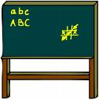CA4HYTAX

**PENCIL4**

__________ ___________ ___________ ___________ __________

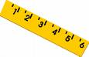





** 🞿**



____________ _____________ ______________ _____________

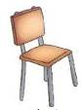



__________ ___________ ___________ ___________ __________

🎔**WRITE THE CORRECT COMMAND UNDER EACH PICTURE**.

* Open the window ✓ Close your book ✓ Silence, please
* Work in pairs ✓ Look at page 6 ✓ Go to the board

✓ Sit down ✓ Raise your hand

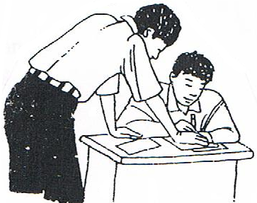

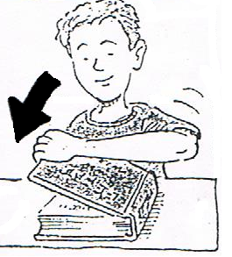

**1.___________________________ 2.___________________________**

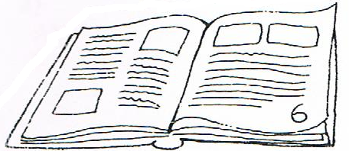

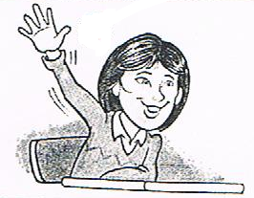

**3.___________________________ 4.___________________________**

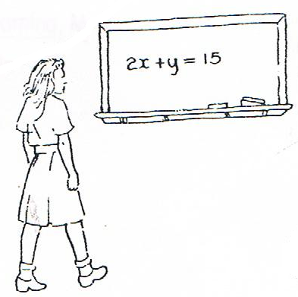



**5.___________________________ 6.___________________________**

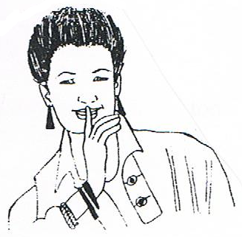



**7.___________________________ 8.___________________________**

🎔**WRITE THE CORRECT EXPRESSION IN THE CORRESPONDING BUBBLE**.

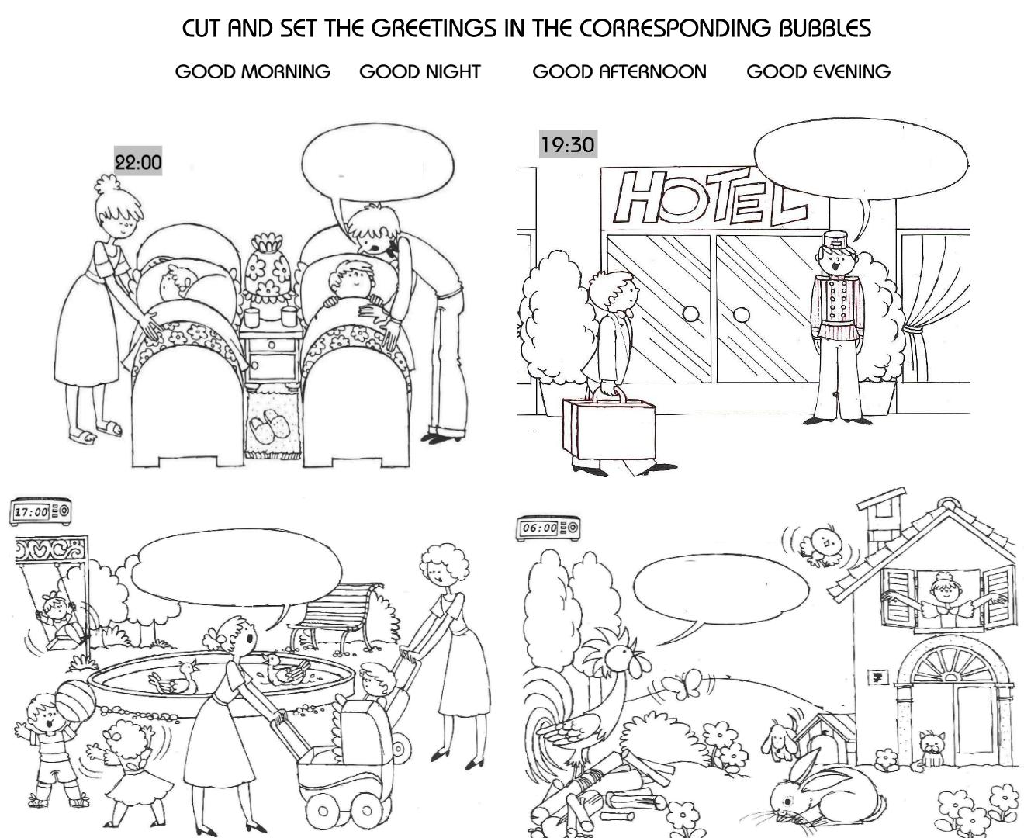

**7:30 p.m.**

**10:00 p.m.**

**6:00 a.m.**

**5:30 p.m.**