###### CURRIDABAT HIGH SCHOOL

**7th**

**ENGLISH DEPARTMENT**

**Practice #1 First Period // 2020**

**Teacher: Lydia Villegas J. H**

**STUDENT:** __________________________ **Group: 7-** ___

**Parent’s Signature ________________**________

A. **Look at the pictures and complete the conversations. Use the expressions in the box.**

### EXPRESSIONS

* See you later.
* Hello Jimmy. Niece to meet you.
* What’s up٫ Rodrigo?
* Hello, Flor. Nice to meet you, too.
* Hello Roberto!
* Flor, this is my friend Jimmy.
* Bye, take care.



 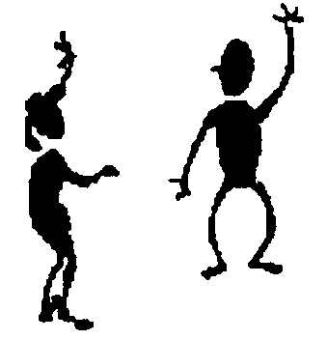

B. **MATCHING.**

**In COLUMN 1 you have forms of verb “be ”. In COLUMN 2 you have sentences.**

**Match the correct form of verb “To be ” to the corresponding sentence. You may repeat.**

# COLUMN 1 COLUMN 2

1. The computer __________ on the desk.

2. I __________ from Perú.

**am**

3. The books _________ on the backpack.

**is**

4. Helen __________ a teacher.

5. Fernanda and I __________ are talking.

6. I __________ student.

**are**

7. Robert __________ in the house .

8. Mrs. Leiva __________ playing.

C. **Choose the correct alternative to complete the sentences. Circle the correct option.**

1. Diana is pretty. ( He – She – You) is a good student.

2. ( He – You – I ) am in the 7th grade.

3. Mario is my friend. ( I – We – He) is funny.

4. The dictionaries are red. ( They – It – He)

5. Emilia and Emma are nice. (She – They – He) are friends.

6. You and I like chocolate. (They – We – You) like sweets.

7. The cat is black. ( It– They – We) is in the tree.

8. That book is new. _____ is very interesting ( They – It – He)

D. Answer the following questions about YOUR personal information. (6pts)

1. What’s your name?

__________________________________________________

2. What’s your last name?

__________________________________________________

3. What’s your address?

__________________________________________________

4. How old are you?

__________________________________________________

5. What’s your telephone number?

__________________________________________________

6. Where are you from?

__________________________________________________