###### CURRIDABAT HIGH SCHOOL

**11-1, 11-2, 11-3**

**11-4, 11-5**

**ENGLISH DEPARTMENT**

**Practice #1 First Period // 2020**

**Teacher: Lydia Villegas J. H**

**STUDENT:** __________________________

**Parent’s Signature ________________**________

🞿 Write “ A ” (if the table manner is appropriate) or “ I ” (if the table manner is incorrect) to indicate the behavior at the table in our country.

1._____ When you sit down to eat, use a napkin to clean your mouth if necessary.

2._____ Clean your hands on the tablecloth or your clothes.

3._____ Put only small pieces of food into your mouth.

4._____ Bring your face toward the plate.

5._____ Never crumple your napkin

6._____ Don’t close your mouth when you chew.

7._____ Don’t hold the fork or knife like a dagger.

🞿 Classify the following food into each the correct food group.

Pasta – mangoes – beef – shrimp – green beans – tomatoes – beans - turkey – rice – broccoli – peppers – strawberries – lamb – potatoes butter – cheesecake – bananas – bread – salmon – chicken – eggs – oil – milk – noodles – chocolates – yogurt – cassava – sweet potato – corn

|  |  |  |  |  |  |  |  |
| --- | --- | --- | --- | --- | --- | --- | --- |
| Fruit | Seafood | Poultry | Meat and fish | Dairy | Vegetables | Starches | Fat, oil and sugar |
|  |  |  |  |  |  |  |  |
|  |  |  |  |  |  |  |  |
|  |  |  |  |  |  |  |  |
|  |  |  |  |  |  |  |  |
|  |  |  |  |  |  |  |  |

🞿 Translate the following cooking verbs:

add _______________ boil _______________ pour _______________

chop_____________ cut _______________ wash _______________

beat _____________ shake _____________ dry_____________

drain_______________ wash_______________ strain _______________

grill ________________ stretch ________________ bake_____________

🞿Write an example:

a carton of _________ a jar of ____________ a stick ____________ a bar of ___________

a can of ___________ a half of __________ a bag of ____________ a box of ____________

a bag of ___________ a bunch of ____________ a pinch of __________ a loaf of ____________

🞿Write under each picture the correct cooking verb.

**WORD BANK**: broil - peel – slice – spread – mash – squeeze – stir – grate – whisk - sprinkle

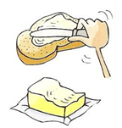 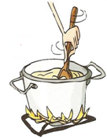 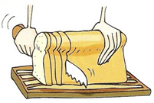 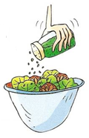 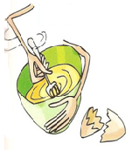

**____________ ___________ _____________ ____________ ____________**

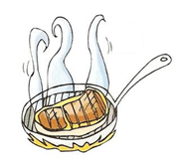 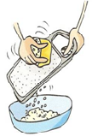 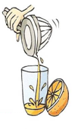 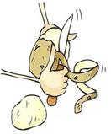 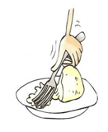

**____________ ___________ ___________ __________ __________**

🞿 Write 5 healthy habits 🞿 Write 5 unhealthy habits

_______________________________ ________________________________

_______________________________ ________________________________

_______________________________ ________________________________

_______________________________ ________________________________

_______________________________ ________________________________