**List of common professions in English.**

**List of Jobs Image**

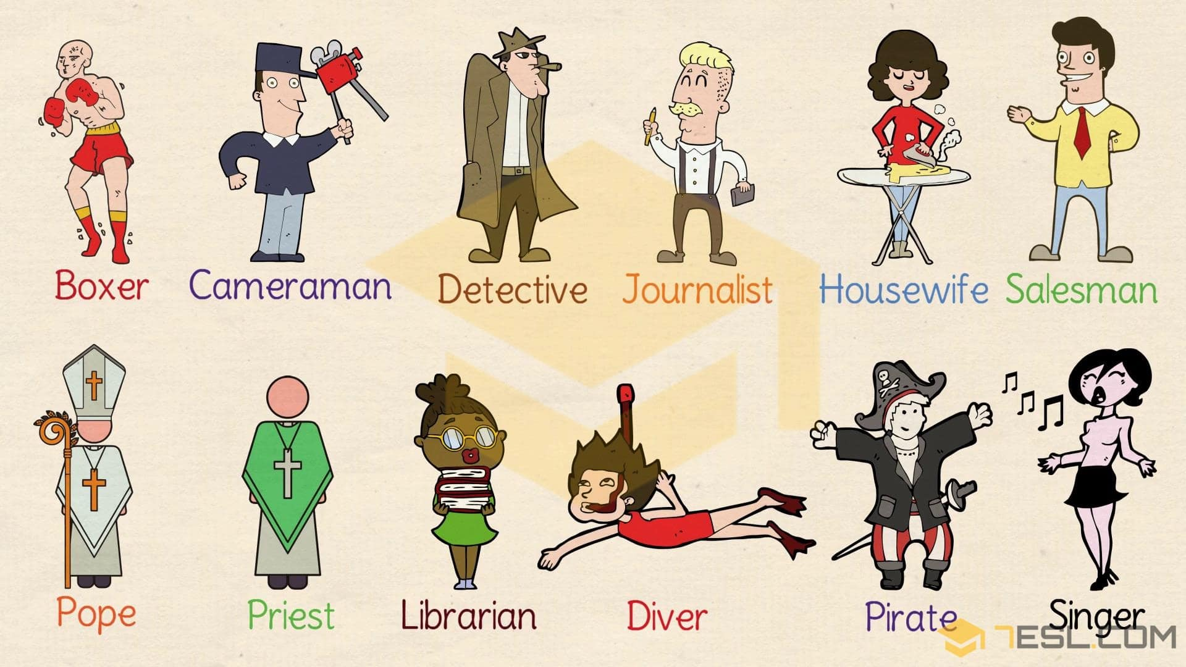

**Use**

**Answer the following questions by using vocabulary above . you must use subject verb and predicate.**

**What does a boxer do ?**

**___________________________________________________________**

**What does a journalist do?**

**___________________________________________________________**

**What does a librarian do?**

**__________________________________________________________**

**What does a salesman do?**

**____________________________________________________________**

**What does a singer do ?**

**____________________________________________________________**

**What does a housewife do?**

**_________________________________________________________**

**List of Jobs and Occupations with Pictures and Examples**

List of different types of jobs in English with examples sentences illustrated with images.

**Waiter**

– The **waiter** brought up the next dish.



**Paramedic**

– A **paramedic** bandaged his foot.



**Dentist**

– You should visit your **dentist** at least twice a year.



**Train conductor**

– He is a **train conductor**.



**Nurse**

– The **nurse** should try to develop empathy between herself and the patient.



**Electrician**

– We need an **electrician** to mend the iron.

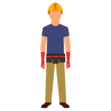

**Doctor**

– The **doctor** forbids him to smoke.



**Businessman**

– The rich **businessman** gave his whole fortune to the hospital.



**American football player**

– I was a fairly good **American football player** in my youth.

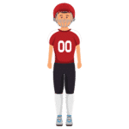

**Student**

– The teacher told the**student** to pay attention to his spelling.



**Surgeon**

– The **surgeon** is performing an eye operation.



**Doorman**

– I showed the **doorman** my card and he gave a friendly nod.



**Secretary**

– My **secretary** will phone you to arrange a meeting.



**Soldier**

– He wants to be a **soldier** when he grows up.



**Repairman**

– The **repairman** installed an iron latch on the door.



**Scientist**

– Einstein was a great **scientist**.

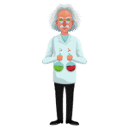

**Reporter**

– She was a TV **reporter** and worked long hours.



**Construction worker**

– My father is a temporary **construction worker**. He moves around all the time.



**Professor**

– Tom reported his discoveries to the **professor**.

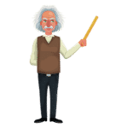

**Police officer**

– I was a **police officer** in the city of New York.



**Postman**

– The **postman** has brought a parcel for you.



**Photographer**

– I think she will be successful as a **photographer**.



**Pilot**

– The **pilot** inquired about the weather condition.



**Painter**

– The young **painter** has exhibited in several galleries.



**Mechanic**

– The **mechanic** was busy repairing the machine.



**Magician**

– The **magician** conjured a rabbit out of his hat.



**Lifeguard**

– There is always a **lifeguard** to ensure that no one comes to any harm.



**Lunchroom supervisor**

– He is a l**unchroom supervisor** at a school.



**Clown**

– She dressed up as a **clown** with a white face and red nose.



**Housekeeper**

– You need a **housekeeper** to nurse your property.



**Gardener**

– The **gardener** mows the grass regularly.



**Footballer**

– The **footballer** took a strike at the goal.



**Forest ranger**

– The group was noticed by a **forest ranger**, who notified border guards.



**Builder**

– Her father was a **builder** in Birmingham.



**Foreman**

– The **foreman** is always swearing at the workers.



**Farmer**

– The **farmer** grows potatoes in this field.



**Flight attendant**

– The **flight attendant** welcomed us aboard.



**Fireman**

– The **fireman** sent jets of water into the burning house.

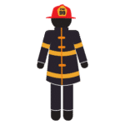

**Engineer**

– The young **engineer** rejoiced in his success.



**Carpenter**

– The **carpenter** was [hammer](https://dictionary.cambridge.org/dictionary/english/hammer)ing in his workshop.



**Architect**

– He is the **architect** who planned the new shopping centre.



**Boxer**

– The **boxer** has fought many opponents.



**Cameraman**

– A **cameraman** and the art director were injured in the incident.



**Detective**

– Sherlock Holmes is a famous **detective** in stories.



**Journalist**

– My job as a **journalist** is to expose the truth.

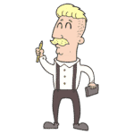

**Housewife**

– I don’t want to be a **housewife** after marriage.

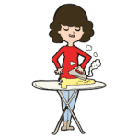

**Diver**

She wants to become a **diver**.



**Pope**

– He was the first **pope** to visit the White House.



**Priest**

– She asked the **priest** to pray with her.



**Salesman**

– He is still a **salesman** and can relate to the situation.



**Librarian**

– The **librarian** entered a new book in the catalogue.



**Singer**

– She’s a **singer** with a band.



