**Liceo de Curridabat**

**Teacher: Kattia Arce Trejos**

**Practice #3 Period: I Year: 2020**

**Date: Wednesday, March 25th, 2020**

**Level: 9 th grade**

**Name: _________________________________________________**

**Parents`signature__________________________________________**

**1. Read the text. Complete the following chart.**

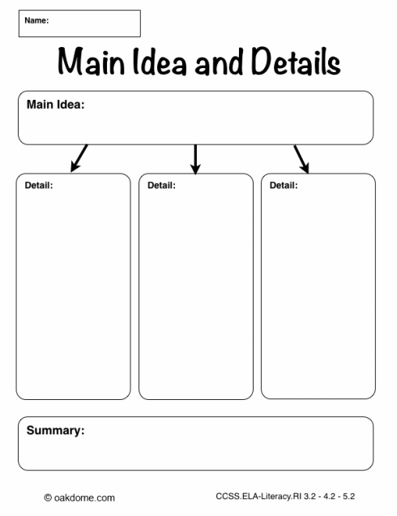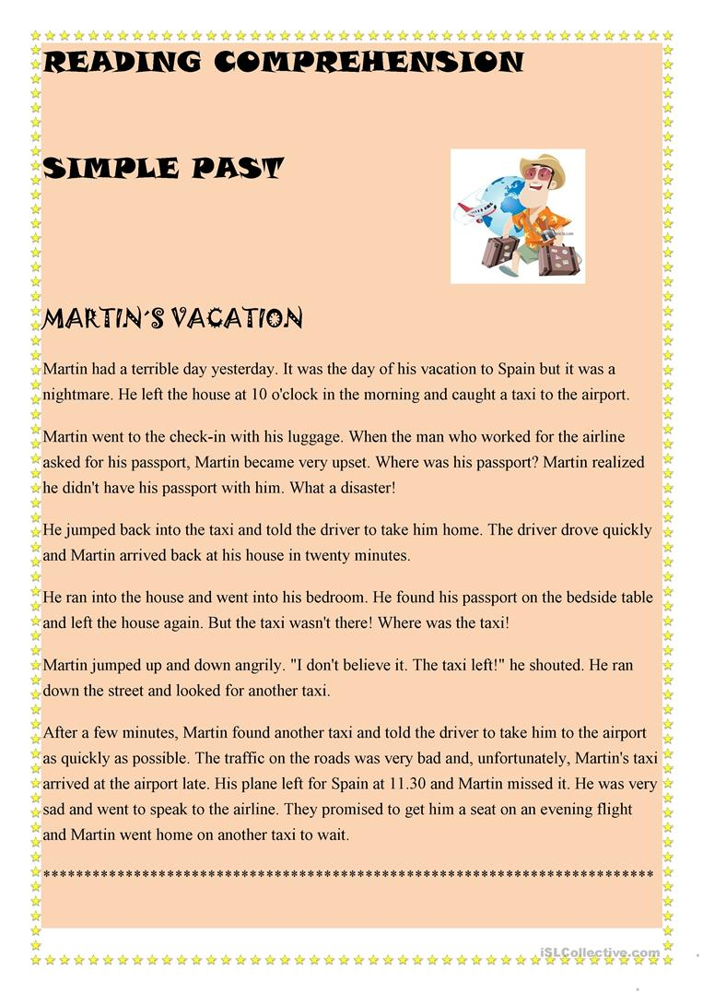

2. Read the text.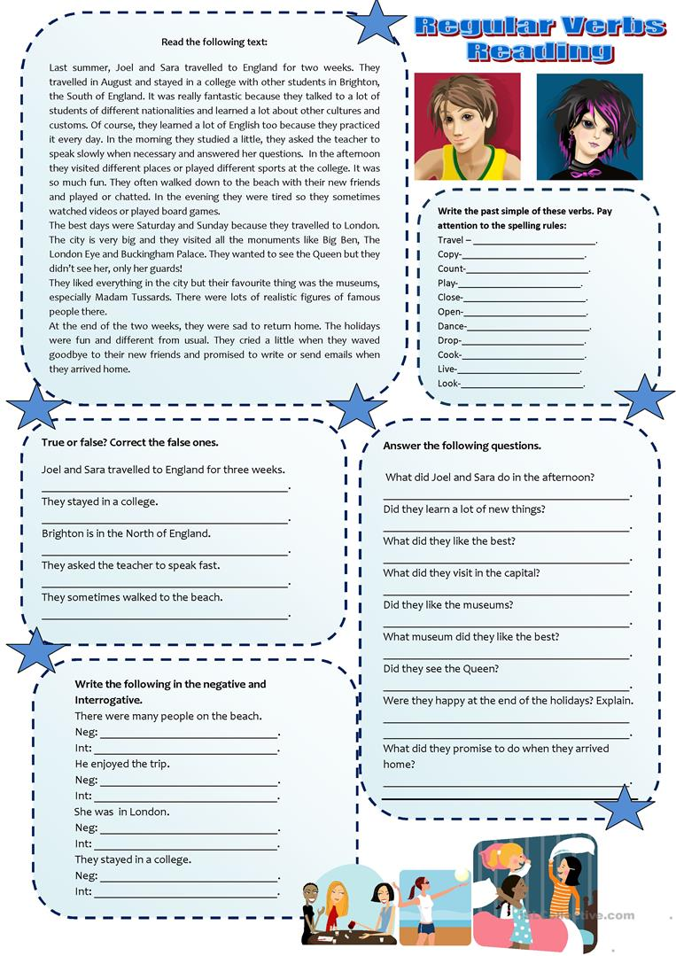

3. Complete the sentences using the verb in parentheses in simple past tense.

1. Mark and Tommy_______________________ (play) soccer yesterday.
2. Thomas________________________ (do) karate last week.
3. Allison _______________________ (practice) volleyball last month.
4. They ______________________ (go) fishing yesterday.
5. Charles _____________________ (practice) basketball last week.

4. Describe your favorite sports. Write six sentences with the description of the sport and the implements.

1.________________________________________________________________________

2.________________________________________________________________________

3.________________________________________________________________________

4.________________________________________________________________________

5.________________________________________________________________________

6._________________________________________________________________________